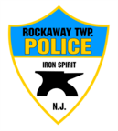
Rockaway Township Police Department

Integrity, Honesty, Fairness, Respect & Compassion

monthly REPORT
JANUARY 2026

3802 | Calls for service/incidents/activity
77 | Motor vehicle crashes
212 | Motor vehicle encounters
2 | Domestic violence incidents
192 | Fire/Medical/911
5 | Adult arrests
1 | DWI
56 | Alarm Responses
7 | Community Policing Events
2527 | Residential/Commercial/ School property checks
12 | Assist other agencies
133 | MV. Tickets

