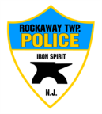
Rockaway Township Police Department

Integrity, Honesty, Fairness, Respect & Compassion

monthly REPORT
February 2026

3653 | Calls for service/incidents/activity
68 | Motor vehicle crashes
231 | Motor vehicle encounters
6 | Domestic violence incidents
180 | Fire/Medical/911
6 | Adult arrests
4 | DWI
46 | Alarm Responses
8 | Community Policing Events
2280 | Residential/Commercial/ School property checks
20 | Assist other agencies
168 | MV. Tickets

