Nov. 28, 2018
Official News Release
For Immediate Release

NEW ONE-STOP, ONLINE APPLICATION ALLOWS MORRIS COUNTY’S OLDER RESIDENTS TO EASILY APPLY FOR AND ACCESS STATE BENEFITS
Pharmaceutical Assistance, Medicare Help, Utility Assistance and Other Programs

Older Morris County residents and disabled residents are now just one click away from important benefits under the NJSave system that has been launched by the state Department of Human Services, and which is now available for residents in Morris County.

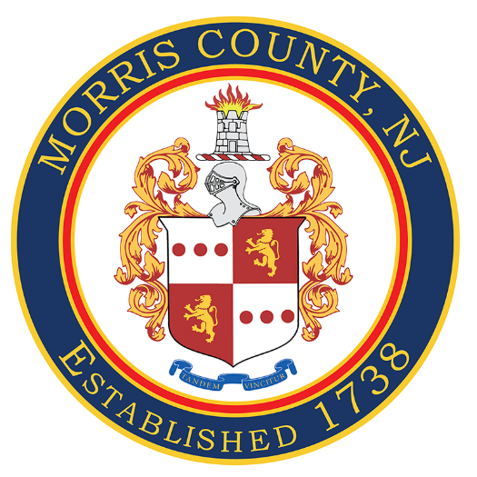
The goal of the new online application system is to make it easier for older residents with low-incomes and persons with disabilities to apply for benefits and possibly save on Medicare premiums, prescription costs, heating costs, and other living expenses.

Instructions and a step-by-step YouTube tutorial are available on the state Division of Aging Services’ website to help guide older residents and their family members.

NJSave allows residents to use a single online application to check eligibility for various assistance programs.

Included are Medicare Savings Programs, which help eligible individuals pay their Medicare premiums and copays; New Jersey’s Pharmaceutical Assistance to the Aged and Disabled (PAAD), which helps save money on prescription drug costs; and the Lifeline Utility Assistance Program (see full list below).

Prior to this, individuals had to fill out a paper eligibility application for each program.

“NJSave will help older New Jerseyans and their families with a simpler way to check out the programs and services available to them,” said Carole Johnson, Commissioner of the Department of Human Services.

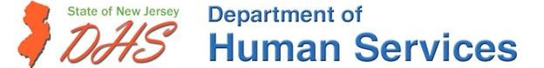

“We are proud to partner with the state on this new online program,’’ said Morris County Director of Human Services Jennifer Carpinteri. “All of our residents’ benefit applications now can be kept in one secure location on your computer to make it easier for you to find your information and update it when needed.’’

“We know new technology can be daunting. If you need help, we urge you to enlist a family member or caregiver to get you started. Once you get used to it, I think you will find the new system makes the benefits process much easier to navigate,’’ said Freeholder Kathy DeFillippo, the county governing board’s liaison on human and social services issues.

Under the new system, eligible residents now can fill out the application and submit supporting documents completely online. Applicants also will be able to create an account and save the form so they do not have to complete the entire process in one sitting.

NJSave enrolls eligible applicants into the following programs:
· Pharmaceutical Assistance to the Aged and Disabled (PAAD):
· Hearing Aid Assistance to the Aged and Disabled (HAAAD)
· Lifeline Utility Assistance
· Medicare Savings Programs
· Medicare Part D’s Low Income Subsidy (LIS, also known as “Extra Help”)
· Senior Gold Prescription Discount Program

The application also can be used to screen individuals for numerous savings and assistance programs:
· Universal Service Fund (USF)
· Low-Income Heating and Energy Assistance Program (LIHEAP)
· Supplemental Nutrition Assistance Program (SNAP)

To qualify for the programs, an applicant has to be a resident of New Jersey, meet certain income requirements, and either be 65 years of age or older or between ages 18 and 64 and receiving Social Security disability benefits.

The paper version of the application will remain in use and is available by calling the state Division of Aging Services at 800-792-9745, the County Office on Aging at 973.285-6858, or local pharmacies.
#####

